**Frequently Asked Questions**

Table of Contents

**Are customers / 3rd parties Salesforce accounts part of the scope?** 1

**What will happen on the 6th of August?** 1

**Where can I review the bFO user accounts of my team?** 1

**Some of my team members seem to be missing, is it normal?** 2

**I am asked to validate bFO accounts of Schneider employees who do not report to me, what can I do?** 2

**What steps do I need to follow to validate the access of the bFO users in my team?** 3

**What steps do I need to follow if I need to delegate the user access validation to another person?** 4

**Who can help me?** 5

## **Are customers / 3rd parties Salesforce accounts part of the scope?**

No, they are not affected.

## **What will happen on the 6th of August?**

The bFO users that have been revoked will be deactivated in bFO and the users that have been validated will keep the exact same level of access.

The list of users that will remain unreviewed will be collected the 6th of August and this will be escalated at a higher level for revocation approval.

## **Where can I review the bFO user accounts of my team?**

You can look for your team members in <https://identify.schneider-electric.com/>

Once logged in the tool you can go to Manage User Access

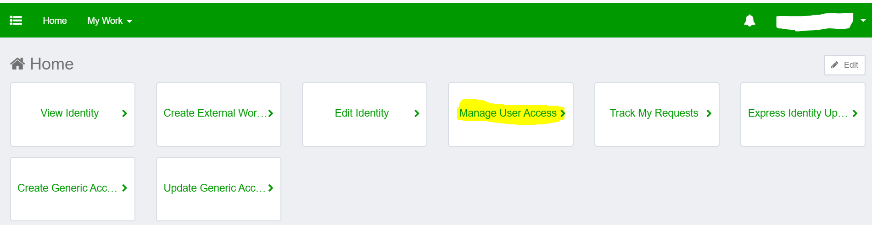

Click on filters

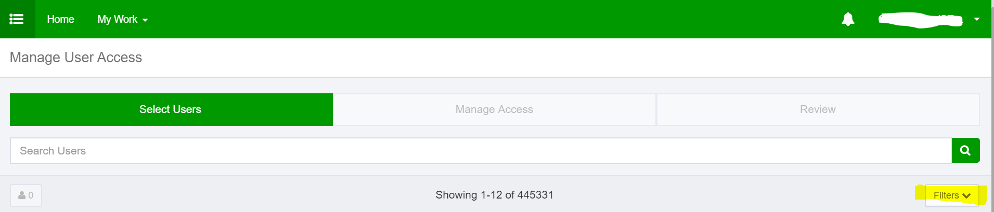

Add your name to the Manager filter, and “bFO” to the Application filter field and click on the Apply button.

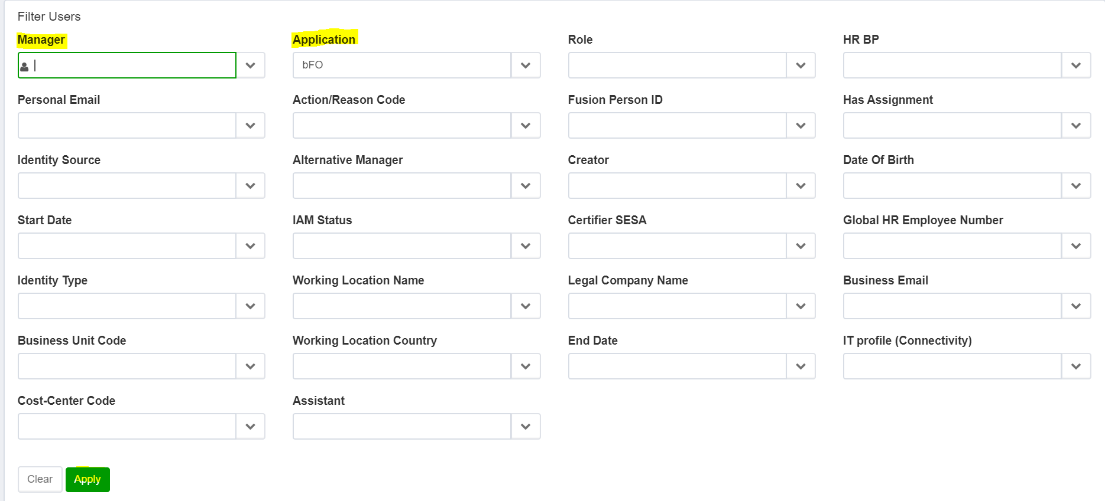

## **Some of my team members seem to be missing, is it normal?**

If you face this situation you can contact [*applicative.user.access.review@se.com*](mailto:applicative.user.access.review@se.com)

## **I am asked to validate bFO accounts of Schneider employees who do not report to me, what can I do?**

You can delegate the validation to their real manager in the same link that you will receive for the validation of your team members.

## **What steps do I need to follow to validate the access of the bFO users in my team?**

Follow the steps below

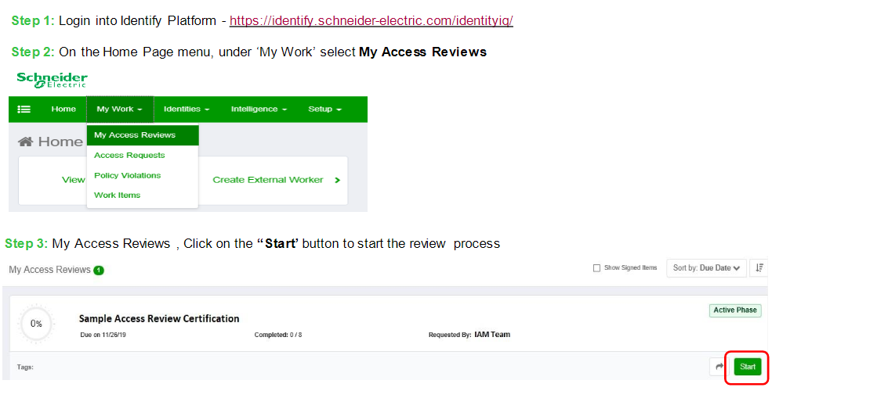

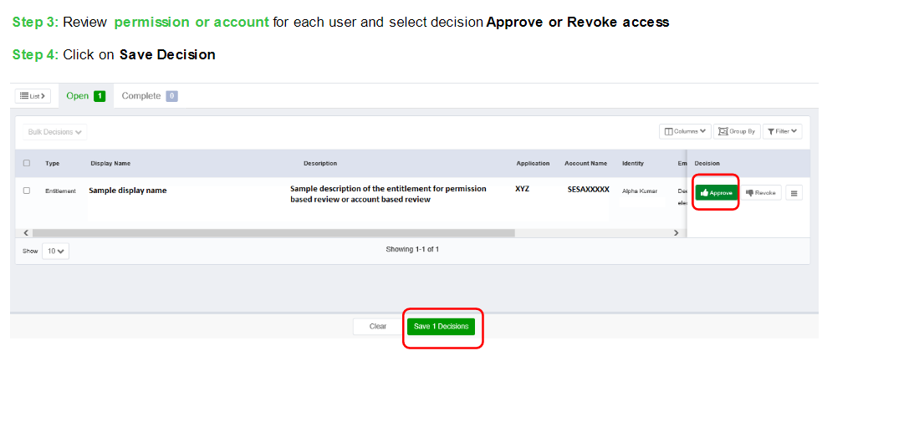

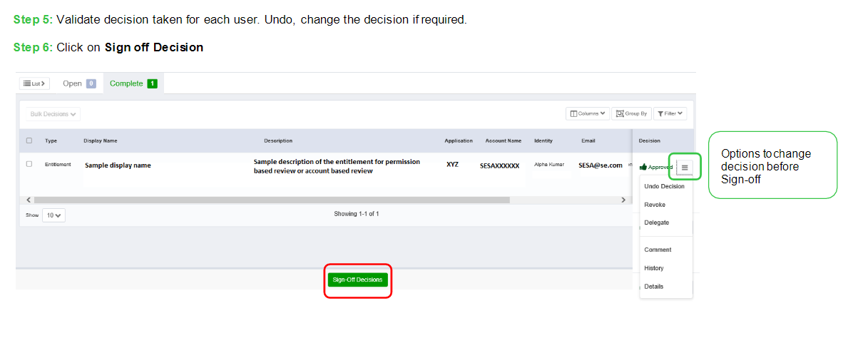

## **What steps do I need to follow if I need to delegate the user access validation to another person?**

Follow the steps below

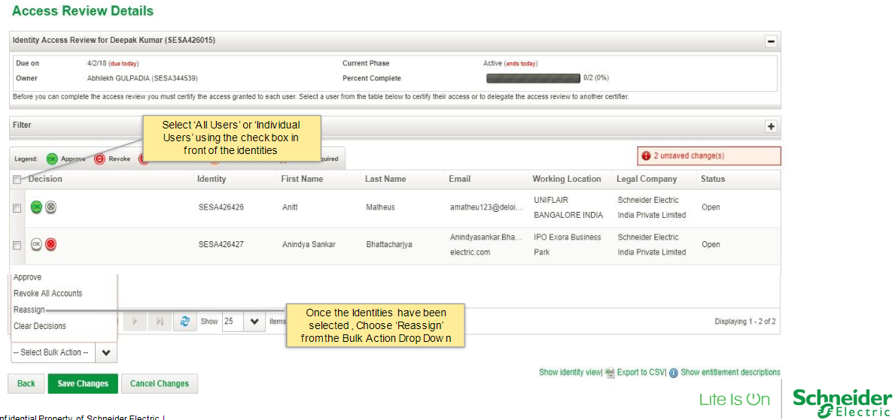

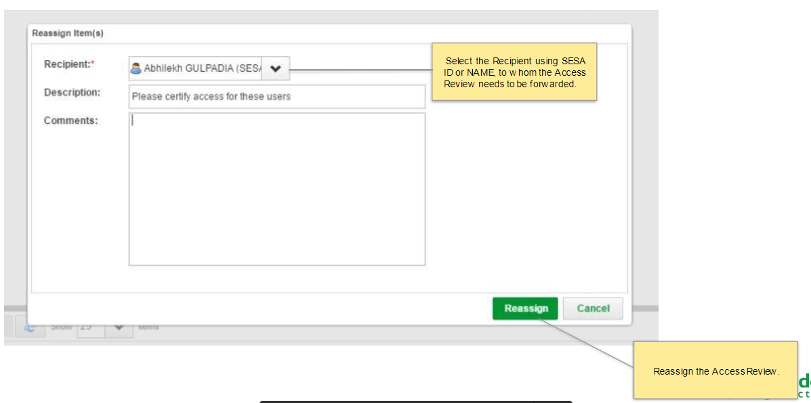

## **Who can help me?**

You can contact the dedicate support team for this campaign at [*applicative.user.access.review@se.com*](mailto:applicative.user.access.review@se.com)